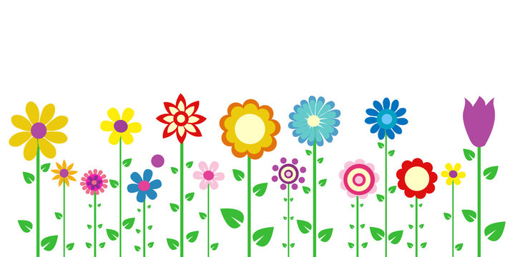

HISTORY:

COAL MINING IN THE NORTH EAST: Children will learn the impact mining has had on the North East. They will learn how technology has changed over time. Civilisation- They will look at environmental change and awareness. Children will recognise why people did things, why events happened and what happened as a result.

Children will explore the different ways of life in a different period, drawing comparisons, describing differences between then and now

Compare pictures or photographs of people or events in the past. They will discuss the reliability of photos/accounts/stories.

Topic will conclude with a visit to Woodhorn Colliery.

P.E. GYMNASTICS

Children will learn about leadership and how to work safely respecting others. They will develop confidence and independence through selecting and applying actions creatively.

ART/DT/ MUSIC

DRAWING:

Children will develop techniques in using pencil to create thick and thin lines. They will explore what happens when we add more pressure to the pencil when drawing lines. Children will look at the work of Kandinsky and learn about how he used shapes and lines to create his masterpieces. They

will then create their own artwork based on the work of Kandinsky.

Our key vocabulary: pressure, thickness, shading.

R.E

WHAT DOES IT MEAN TO BE A MUSLIM (CONTINUED)

PSHE : Relationships and health education: Children will learn to understand and respect the differences and similarities between people. They will learn about the biological differences between male and female animals and their role in the life cycle, the biological differences between male and female children and about growing from young to old and that they are growing and changing.

LITERACY:

This half term children will look at simple recurring literary language in stories and poetry.

They will discuss and clarify the meanings of words, linking new meanings to known vocabulary.

They will learn to spell more words with contracted forms. Write capital letters and digits of the correct size, orientation and relationship to one another and to lower case letters.

Make simple additions, revisions and corrections to their own writing. This half terms books are:

Dr.Xargles Book of Earthlets by Jeanne Willis

The Gruffalo by Julia Donaldson

SPRING ONE

YEAR TWO

SCIENCE:

LIVING THINGS AND THEIR HABITATS

In Science the children will continue to learn about different habitats within their local environment with particular emphasis on micro habitats. They will develop their scientific skills through close observation, classification and categorisation. This unit will encourage the children to build upon their scientific thinking through the comparison of animal habitats in different climates.

The children will also learn about the Season of Spring. They will look at some scientific features including weather, temperature and observable changes in the local area.

I.C.T.

Welcome back children and parents, I hope you have had a good Christmas and A Happy New Year. Here is the outline of your children’s learning for next half term. If you have any queries at any time, please don’t hesitate to ask, my door is always open! ☺ Mrs. Barlow

MATHS:

ADDITION AND SUBTRACTION

SHAPE

Children will learn to describe 2D and 3D shapes using accurate mathematical vocabulary. They will also learn to find 2D shapes in 3D shapes, to arrange shapes into patterns, and to talk about rotation. The key words for this section are 2D, 3D, polygon, line of symmetry, non-polygon, and vertex.

INTRODUCTION TO MULTIPLICATION

Children will recognise, make and add equal groups equal groups. They will be Introduced to the multiplication symbol, multiplication sentences and use arrays to represent multiplication.

Make equal groups – grouping

Make equal groups – sharing